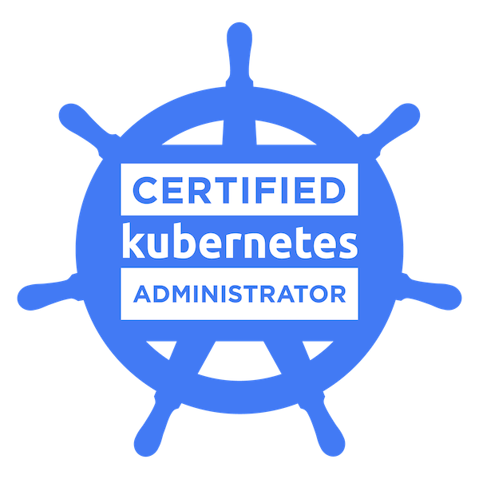  Shiv Narayan Mishra
+91 7799000760
snmishra3008@gmail.com

Profile
Proficiency in DevOps Engineer. To achieve excellence in any work assigned to me and to assist the organization in achieving its goal in consonance with its mission.

Professional Experience

From Aug 2021 to till date Capgemini (Aricent). (Gurgaon)
Senior Consultant (DevOps)

Job Responsiblities : -
- Working on Rakuten Japan project as SRE
- Used Kubernetes to orchestrate the deployment, scaling, and management of Containers.
- Upgraded Kubernetes clusters.
- Understanding of Robin, used at top of Kubernetes layer for ease of storage, Networking and API driven Automation.
- Grafana is used to Monitory 500+ Kubernetes clusters.
- Working on troubleshooting of OS/Drivers/cluster upgrade failures.
- Ansible and shell is used as automation tools to upgrade the OS and containers.

From March 2019 to Jul 2021 Orange Business Services. (Gurgaon)
Consultant (DevOps)

Job Responsiblities : -
- Used Kubernetes to orchestrate the deployment, scaling and management of Docker Containers.
- Upgraded Kubernetes container.
- Providing Level-3 level support for RHEL, SUSE, Ubuntu OS on HP, Dell & virtualization platforms.
- Used CI/CD tools Jenkins, Git/Gitlabs, Jira and automation using Ansible .
- Building policy complaint OS platform images for various public and private cloud platforms.
- Using Jenkins to create job pipeline to bootstrap scripts/playbooks.
- Building shell scripts as per customer requirements.
- Worked on various AWS services like S3, EC2, DNS, Networking and LB
- Studying emerging technology & trends and incorporating them into solutions for customers.
- Validating various enterprise as well as open source products against organization requirements.
- Track vulnerabilities and release patches to internal customers.
- Working with security teams on compliance aspects.
- POC on Disaster Recovery tool i.e. Carbonite/DoubleTake.

Aug 2015 to Feb 2019 - Vodafone Shared Services India. (Pune)
Deputy Manager

Job Responsiblities : -
- Worked on AWS and its services like AWS IAM, VPC, EC2, ECS, EBS, S3, Lambda, ELB, Auto Scaling, Route 53, Cloud Front, Cloud Watch etc.
- Created alarms, monitored & collected log files on AWS resources using CloudWatch on EC2 instance which generates Simple Notification Service (SNS).
- Managed Ansible Playbooks with Ansible modules , implemented CD automation using Ansible, managing existing servers and automation of build/configuration of new servers.
- Experience in developing Splunk queries and dashboards targeted at understanding application performance and capacity analysis.
- Doing automation Job using Jenkin and Puppet/Ansible.
- Working on DevOps task using tools AWS, GIT, Jenkin, Puppet, RabbitMQ etc.
- Create Instances on AWS using EC2 & Cloud Formation.
- Build & Deploy new release automated and manual.
- Managing Vodafone live requests for eight European OpCo’s.
- Responsible for server health checks.
- Troubleshoot in case of any KPI (Key Performance Indicator) fails to its threshold values.
- Re-routing of service through apache rewrite rules or DNS change.
- Troubleshooting OS & Database related issues.
- Creating Monitoring dashboards using Splunk.
- Creating and managing spmi users through oracle database.

Apr 2014 - Aug 2015 - Oracle India pvt. ltd. (Hyderabad)
Technical Consultant

Job Responsibilities -:
- The role involved building, supporting, and refreshing of multi node and multi tier demo environments across multiple product groups (Oracle Fusion, E-Business suite, SBL, Hyperion).
- Archive (snap and tar), Refresh, Restore and Upgrade of demo environments on File system level.
- Responsible for Routine activities on Linux servers.
- Environment migration through VM across racks and pools.
- Maintaining file system, disk issues, logs.
- Troubleshooting OS & Database level tools- Disk Space management, mounting partitions, NFS.
- Automate the task through shell scripting.
- Troubleshooting issues related to infrastructure of demo environments.
- Using EM-12c as the main tool to monitor database and application services for Oracle Apps Unlimited and Oracle Fusion environments.
- Managing complete fusion lifecycle from provisioning of hardware to deployment and then retirement of Environments.
- Monitoring fusion environments through EM12c and finding RCA through deep diving in logs.
- Cronjob Requests, Scheduling a job though crontab.
- NFS (Network File Sharing) configuration.
- Troubleshooting various issues related to services running on linux based servers.

Feb 2011 – Apr 2014 - NIIT Technologies Ltd.(NCR)
Sr. Systems Engineer

Job Responsibilities -:
- Monitoring and troubleshooting Linux based servers, analyzing logs.
- Work area around webhosting, LVM, apache, squid caching, squirm pattern, DNS, etc.
- Worked on Vmware vSphere 5.x
- Build, configure and deploy VMs and templates.
- Handing Disk/CPU Utilization Tickets.
- Performed user account creation, deletion, and configuration.
- Created website availability report on monthly basis.
- Troubleshoot through server ILO.
- Managing IPtable of morris communication.
- Giving RCA for all P1 issues of web-hosting team.
- Participate in conference calls, monitor and track project plans, escalations etc.
- Visited different BSF client locations and give application training at various Battalions and Units.
- Checked and Monitored networks for BSF-Prahari.
- Took feedback and signoff certificates.

Trainings/ Certifications -:
- Kubernetes (CKA)
- Certified Calico Operator: L1
- AWS.
- ITIL v3.
- Ansible.
- Red hat Linux Course from HCL CDC.
- Business Continuity and Disaster Recovery.

Qualifications -:
- B.E from Technocrats Institute of Technology, Bhopal in 2010 with 70.1%
- Standard XII from Sainik School Rewa in 2005 with 63.2%
- Standard X from Sainik School Rewa in 2003 With 68.4%

Personal Details
DOB: 12th of July 1987
Marital status: Married
Passport Number: L8566334

Contact Information
Address: 113, Sarvahit Apartment, Sector 17, Dwarka, NewDelhi, 110075
Mobile No.: 07799000760
Email Id: snmishra3008@gmail.com

Permanent address: Jr.MIG-72, SPM Nagar, Damoh, (MP).
Emergency Contact details (Phone Nos.): 09823778698

